BIOBIN FOR SAFE HANDLING AND DISPOSING OF BIOMEDICAL WASTE DURING COVID '19
Objective:
Aim of the project is to build a movable smart dustbin to help COVID affected patients which can be controlled by android application.
Abstract:
The world’s most populous country is India which faces a major problem in waste management. In India, smart city concept is still new, even though it has received a lot of attention in few years. A society can dispose the waste properly only when dustbins are placed and collected well. Waste collection and sorting is the main advantage of trash management. The major issues in the trash management are bin gets overflowed. This can create to a bad odor which may cause diseases badly. Waste collection, handling and management have been a hazardous task to the sanitary workers in this pandemic era. Various methods have been followed and introduced to handle this biomedical waste. It includes recycling, incineration, reduction and separation at the source. To avoid the spread of covid-19 virus and to help covid-19 affected patients we proposed a smart dustbin system. This smart dustbin is equipped with smart micro controller, level sensing unit, line following sensor unit, network connectivity and wheels. An android application is used to control the movement of dustbin in any direction.
The proposed model can help the COVID affected patients to dispose the waste from their room to outside. It can eliminate the requirement of another person and will avoid the further spread of covid-19 virus.
Existing System:
Existing system uses a BIOBIN to collect and alert the individuals involved in the waste management process. It involves the following components: Smart BIOBIN, ultrasonic sensors, servo motor and Node MCU.

Proposed System:
The proposed smart bin can be move around the surroundings according to user inputs and can also indicate its level. The smart bin can be controlled by android application via BLE sensor and it sends the overflow status to the cloud database. It will reduce the waste management process and avoid the unnecessary entry of employee to quarantine region.
Block Diagram:
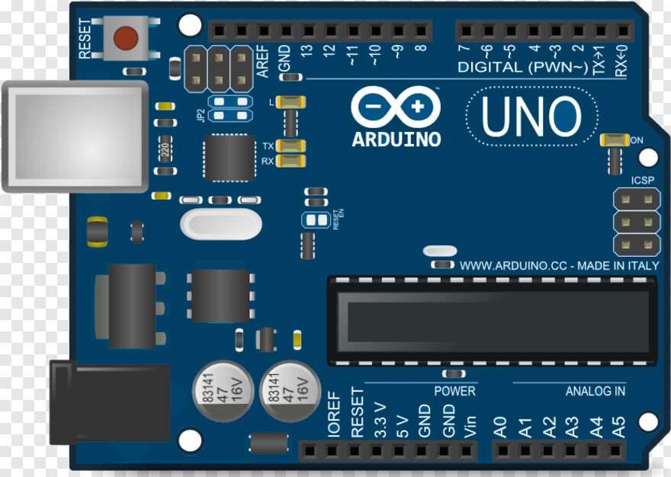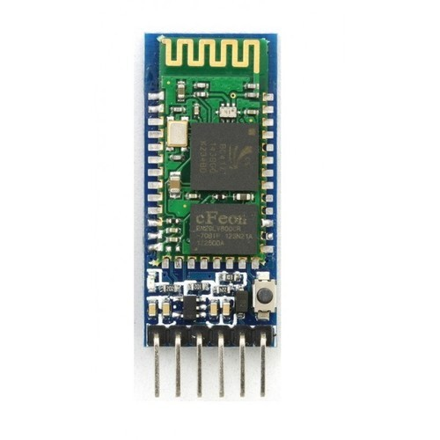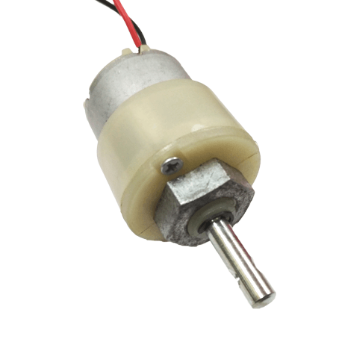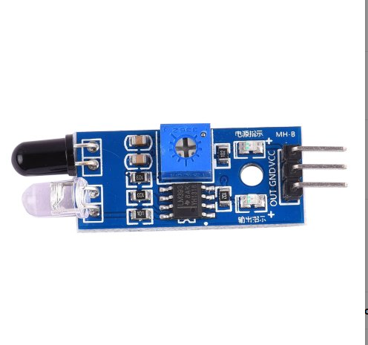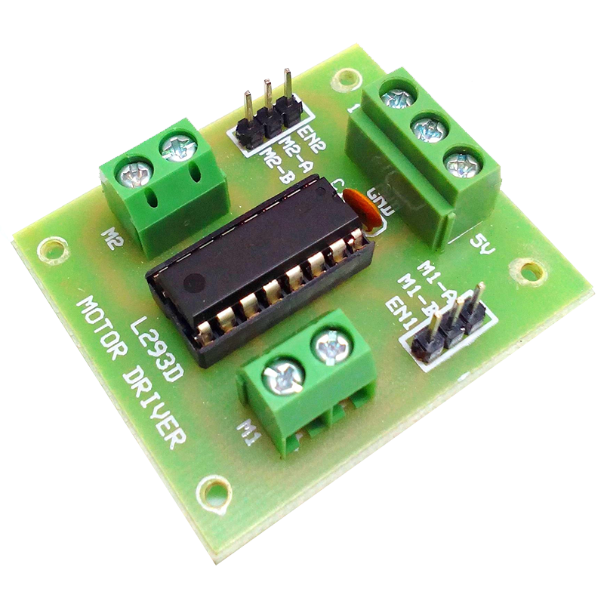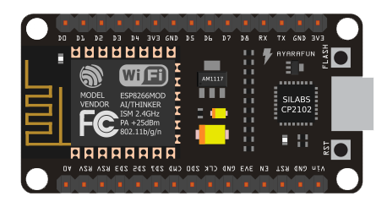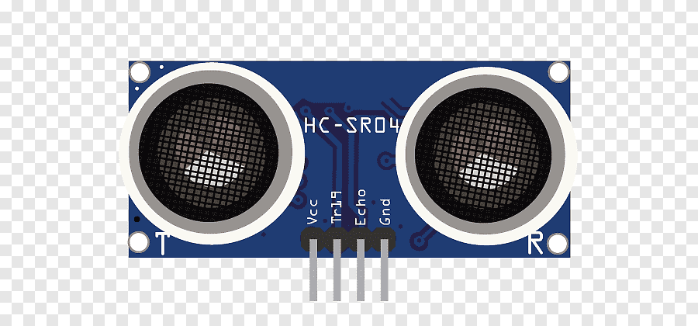
Buzzer
IR sensor
BLE module
Ultrasonic Sensor
Arduino
Node MCU
Cloud Database
Android App
Motor Driver
DC Motor
Hardware Requirements:
- Arduino Uno
- Node MCU
- HC-05 BLE Module
- L293D Motor Driver
- DC Geared Motor (500/1000 rpm)
- Wheels * 2
- Ultrasonic Sensor
- IR sensor
- LED
- Buzzer
- 12v lead acid battery
- Android Mobile
Software Requirements:
- Arduino IDE
- Android Studio
Other Requirements:
- Dustbin

